**Lab 9 - Configure Router-on-a-Stick Inter-VLAN Routing**

**Course Code - Course Name:** - COMP4039 – Network Foundations

**Program:** T433 - Cybersecurity

**Section:** A

**Term:** - Winter 2024

**Group Number:** 06

**Student Names - ID:**

* Prabhjot Singh Sains – 101495218
* Rahul Patel - 101378458
* Jai Deep Rawat - 101503760
* M. Salmaan Mustafa Shah – 10151007

**Lab Report by -** Prabhjot Singh Sains

**Addressing Table**

|  |  |  |  |  |
| --- | --- | --- | --- | --- |
| **Device** | **Interface** | **IP Address** | **Subnet Mask** | **Default Gateway** |
| R1 | G0/0/1.3 | 192.168.3.1 | 255.255.255.0 | N/A |
| G0/0/1.4 | 192.168.4.1 | 255.255.255.0 | N/A |
| G0/0/1.8 | N/A | N/A | N/A |
| S1 | VLAN 3 | 192.168.3.11 | 255.255.255.0 | 192.168.3.1 |
| S2 | VLAN 3 | 192.168.3.12 | 255.255.255.0 | 192.168.3.1 |
| PC-A | NIC | 192.168.3.3 | 255.255.255.0 | 192.168.3.1 |
| PC-B | NIC | 192.168.4.3 | 255.255.255.0 | 192.168.4.1 |

**VLAN table**

|  |  |  |
| --- | --- | --- |
| **VLAN** | **Name** | **Interface Assigned** |
| 3 | Management | S1: VLAN 3  S2: VLAN 3  S1: F0/6 |
| 4 | Operations | S2: F0/18 |
| 7 | ParkingLot | S1: F0/2-4, F0/7-24, G0/1-2  S2: F0/2-17, F0/19-24, G0/1-2 |
| 8 | Native | N/A |

**Instructions**

**Part I:**

* Set up the topology and initialize the devices.
* Initialize and reload the switches and router to clear any existing configuration as needed.

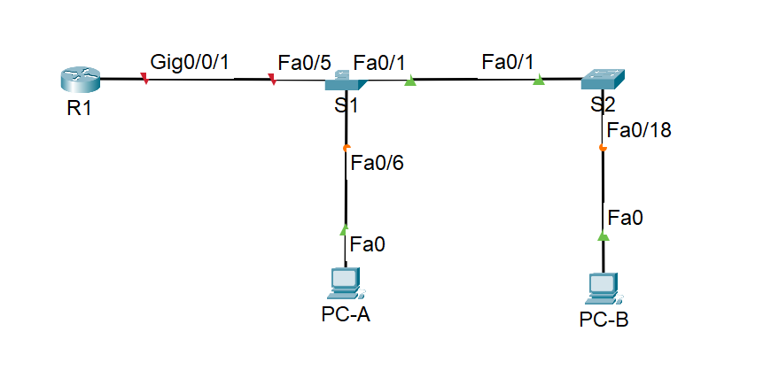

Fig 1 - Topology

**Part II:** Configure PC hosts.

* Refer to the Addressing Table for PC host address information. Use the IP config command to display information.

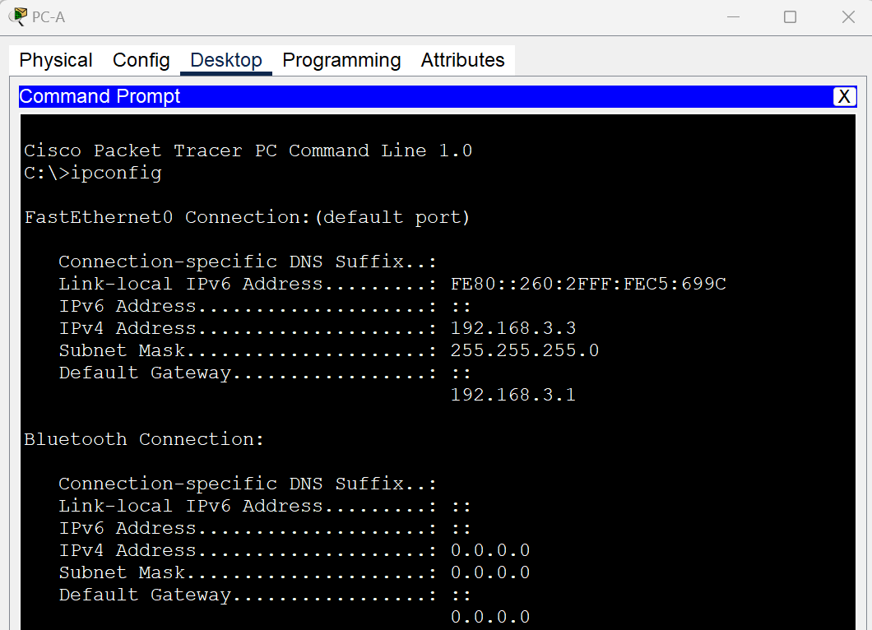

Fig 2- Information displayed in the terminal using the IP config command for PC-A

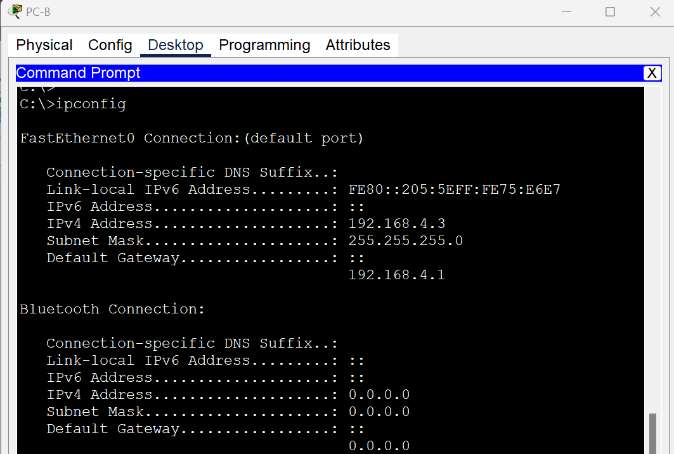

Fig 3- Information displayed in the terminal using the IP config command for PC-B

**Part III:** Configure basic configuration for the router and Switches:

1. Assign a device name to the router and switches.
2. Disable DNS lookup to prevent unwanted DNS lookups.
3. Assign the class as the privileged EXEC encrypted password.
4. Assign Cisco as the console password and enable login.
5. Assign Cisco as the VTY password and enable login.
6. Encrypt the plaintext passwords.
7. Create a banner that warns anyone accessing the device that unauthorized access is prohibited.
8. Save the configuration. Use the copy command to save the running configuration to the startup file on non-volatile random-access memory (NVRAM).

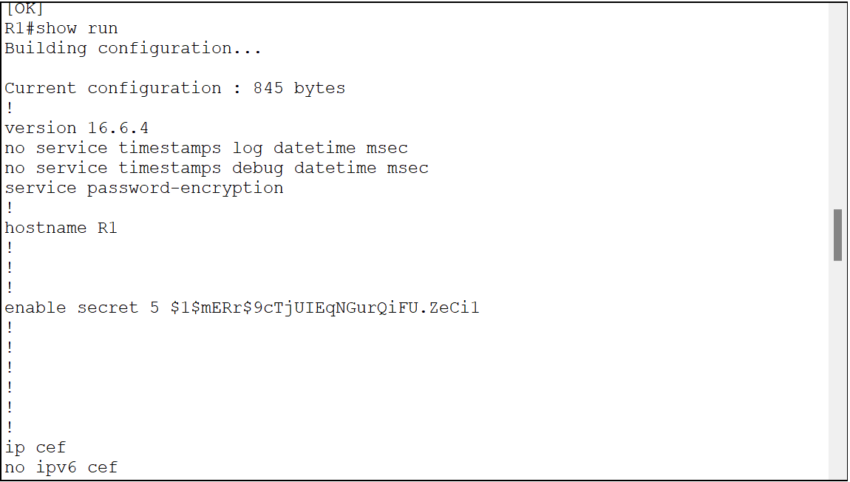

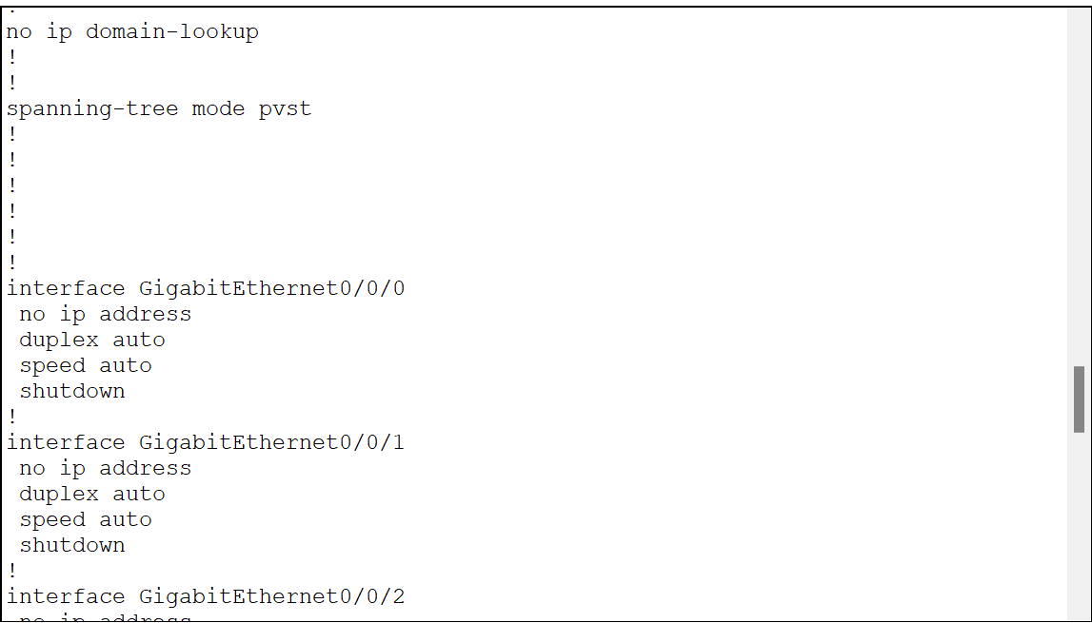

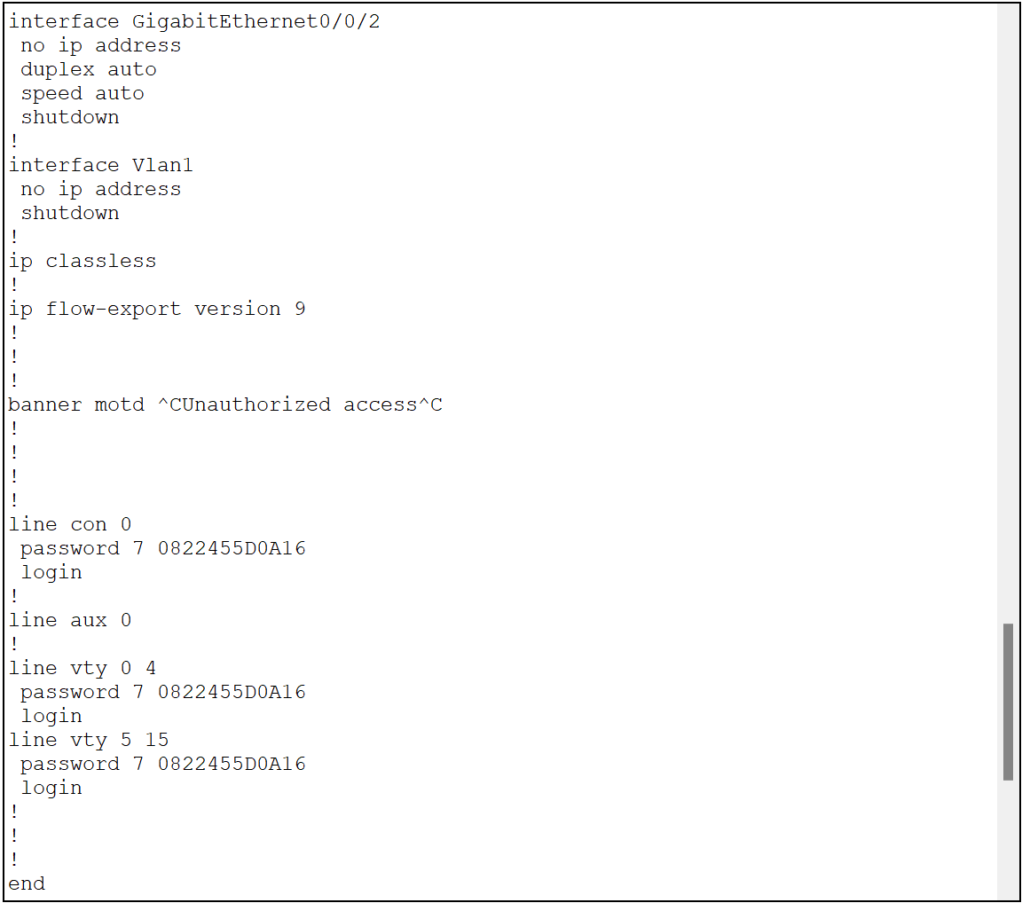

Fig 4- Information displayed in the terminal using the show run command from R1.

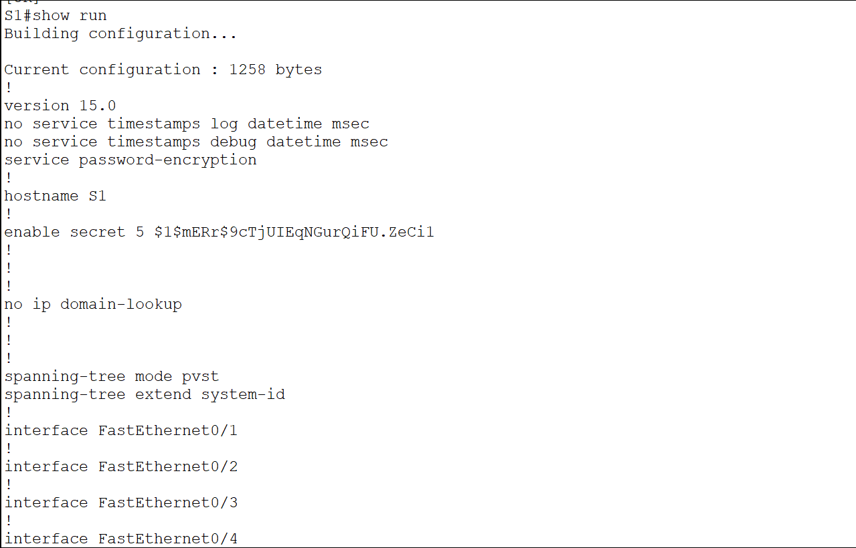

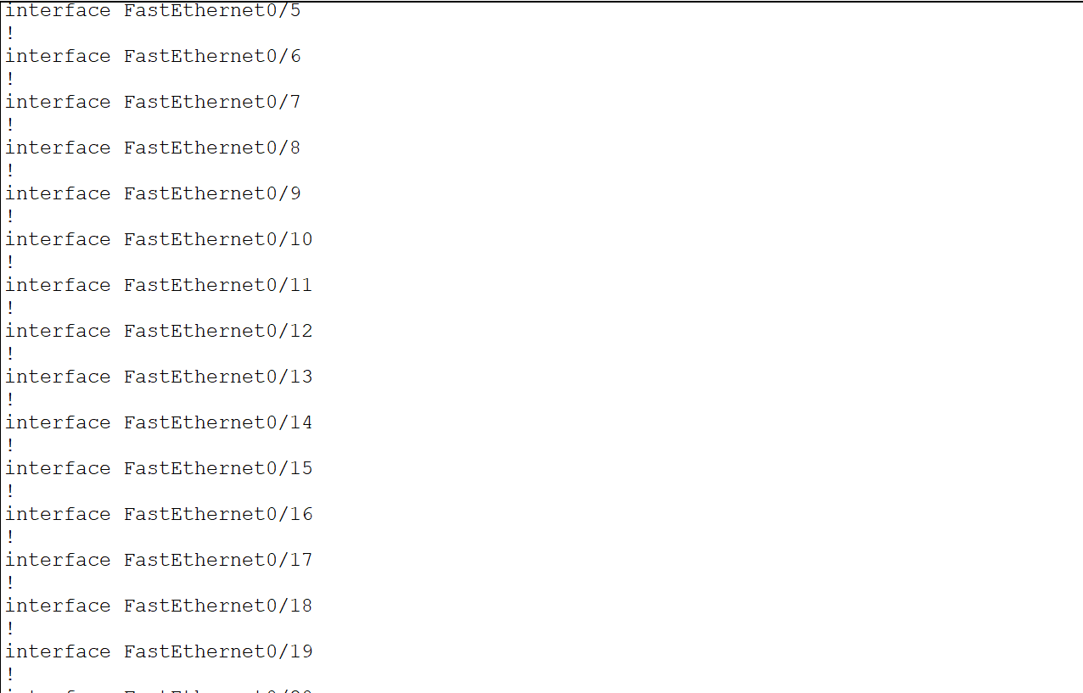

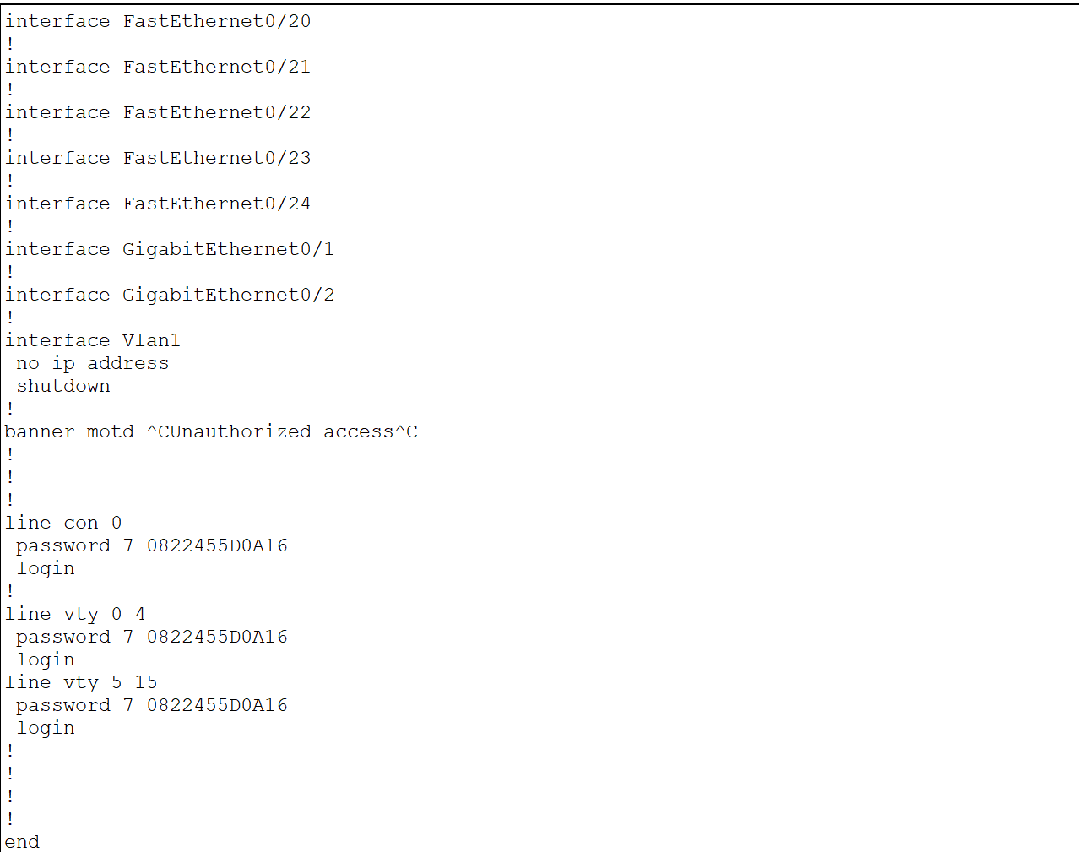

Fig 5- Information displayed on the terminal using the show run command from S1.

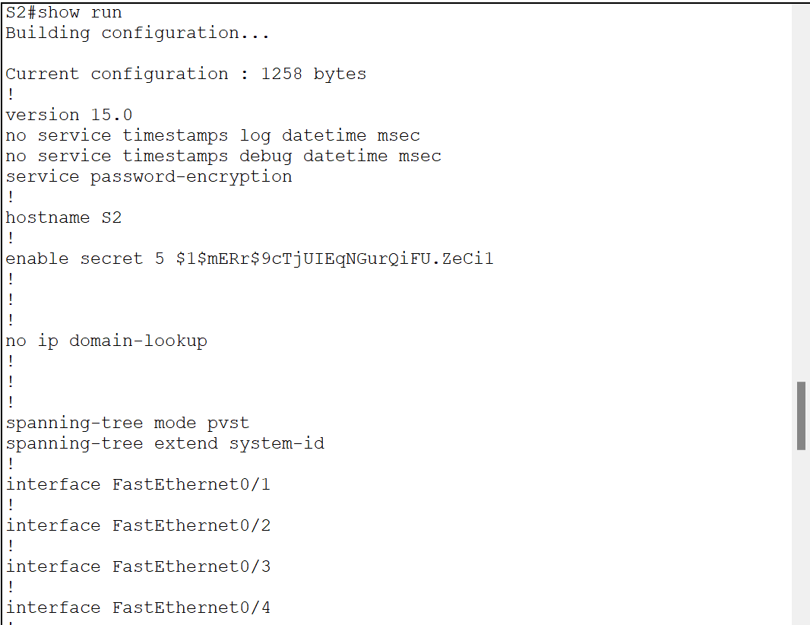

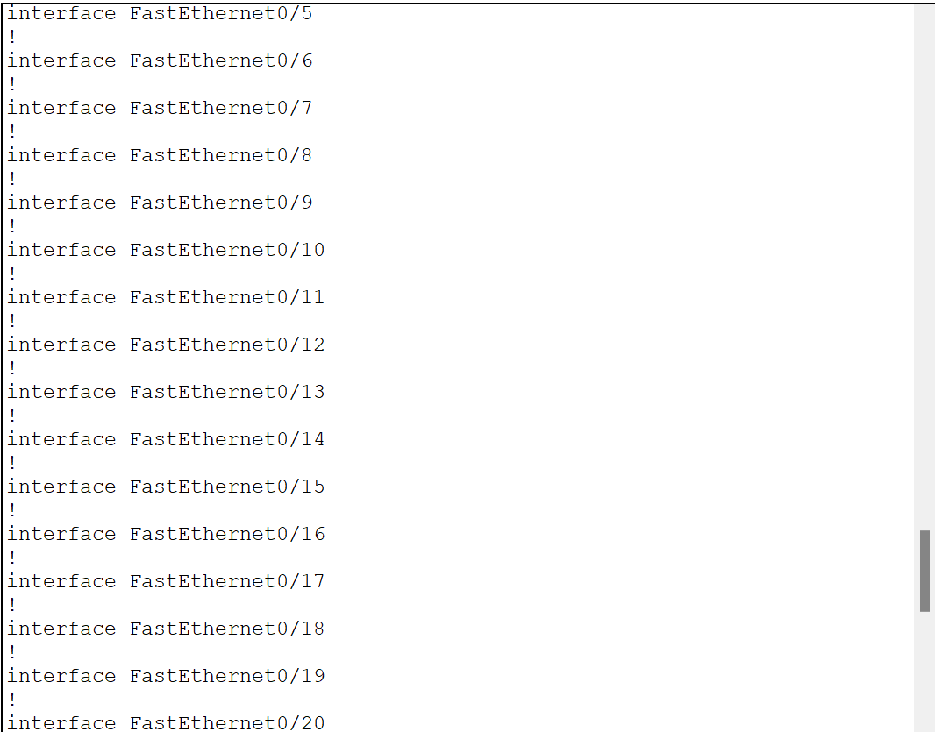

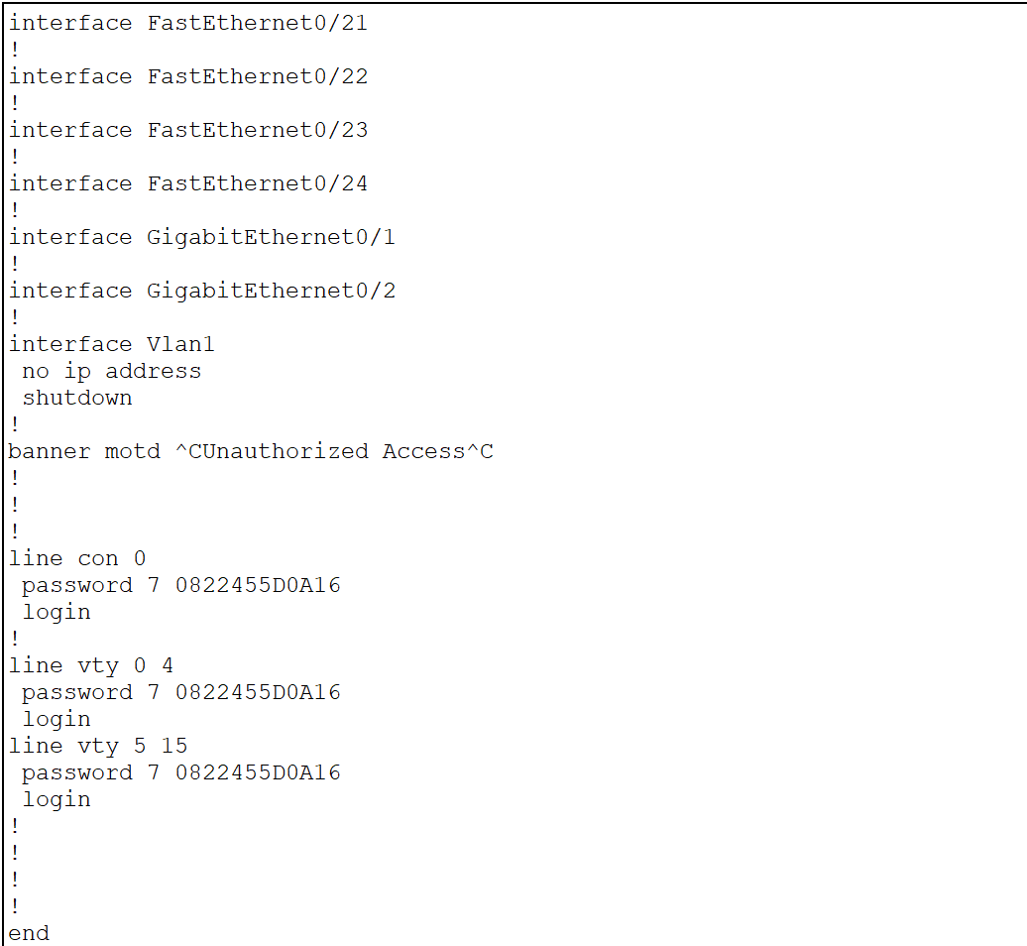

Fig 6- Information displayed on the terminal using the show run command from S2.

**Part III:** Create VLANs and Assign Switch Ports:

1. Create and name the required VLANs on each switch from the table above.
2. Configure the management interface on each switch using the IP address information in the Addressing Table.
3. Assign all unused ports on the switch to the ParkingLot VLAN, configure them for static access mode, and administratively deactivate them.
4. Assign used ports to the appropriate VLAN (specified in the VLAN table above) and configure them for static access mode. Be sure to do this on both switches.

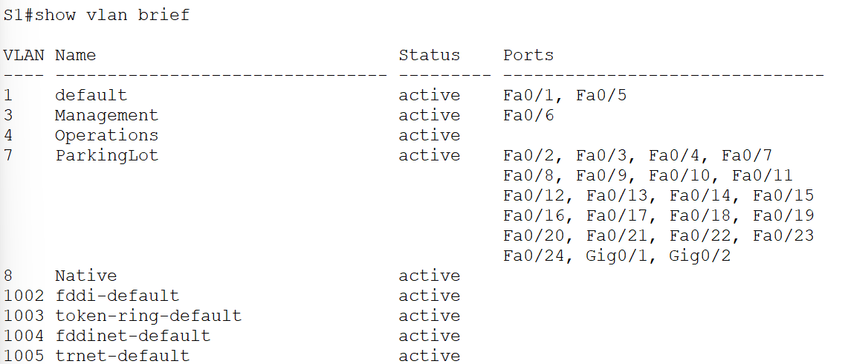

Fig 7- On S1 Information is displayed on the terminal using the show vlan brief command.

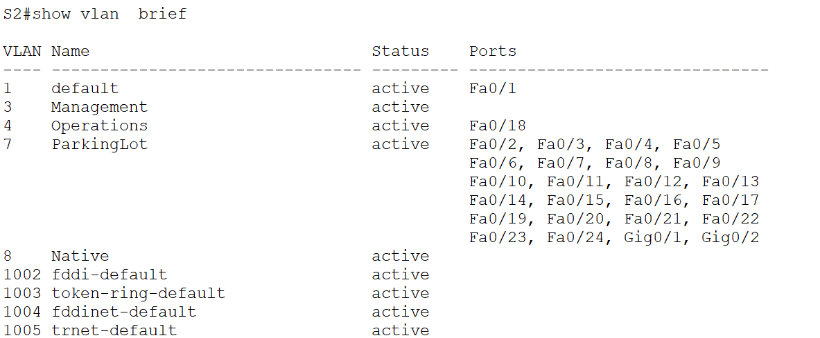

Fig 8- On S2 Information is displayed on the terminal using the show vlan brief command.

**Part IV:** Configure an 802.1Q Trunk Between the Switches and between Router/S1.

1. Manually configure trunk interface F0/1 on both switches.
2. Set the native VLAN to 8 on both switches.
3. Specify that only VLANs 3, 4, and 8 are allowed to cross the trunk.
4. Manually configure S1’s trunk interface F0/5. Use the same trunk parameters as F0/1.

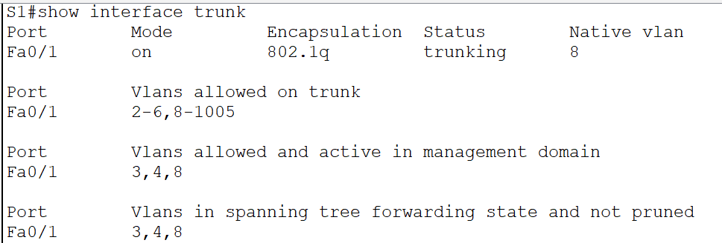

Fig 9- Information displayed on the terminal using the show interface trunk command.

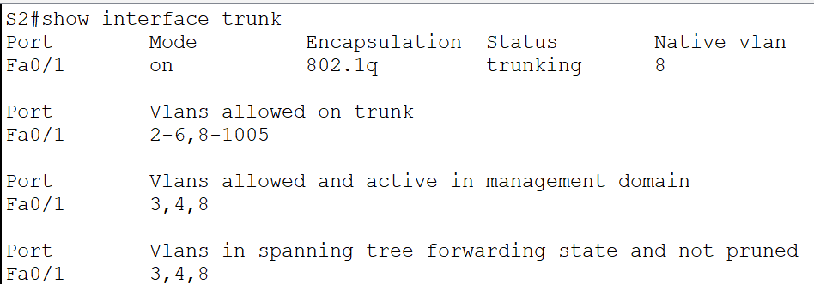

Fig 10- Information displayed on the terminal using the show interface trunk command.

**Part V:** Configure Inter-VLAN Routing on the Router.

1. Activate interface G0/0/1 on the router.
2. Configure sub-interfaces for each VLAN as specified in the IP addressing table. All sub-interfaces use 802.1Q encapsulation. Ensure the sub-interface for the native VLAN does not have an IP address assigned. Include a description for each sub-interface.

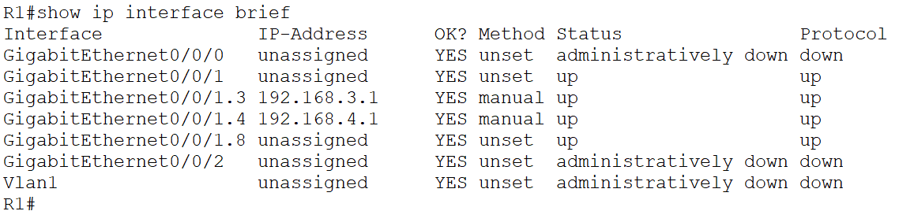

Fig 11- On R1, Information is displayed on the terminal using the show IP interface brief command.

**Part VI:** Verify that Inter-VLAN Routing is working.

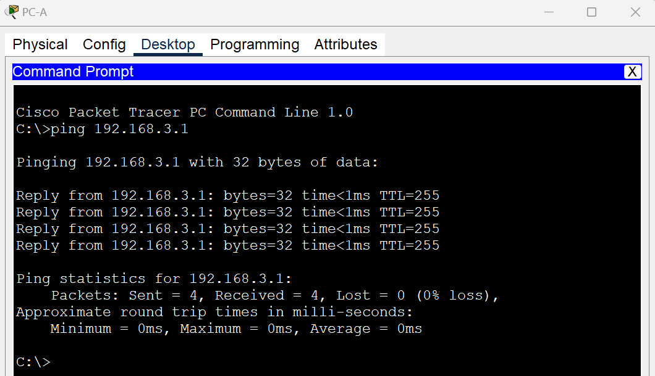

Fig 12- Ping from PC-A to its default gateway.

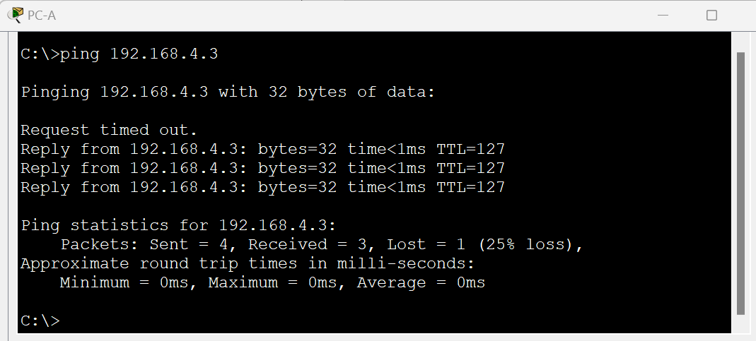

Fig 13- Ping from PC-A to PC-B.

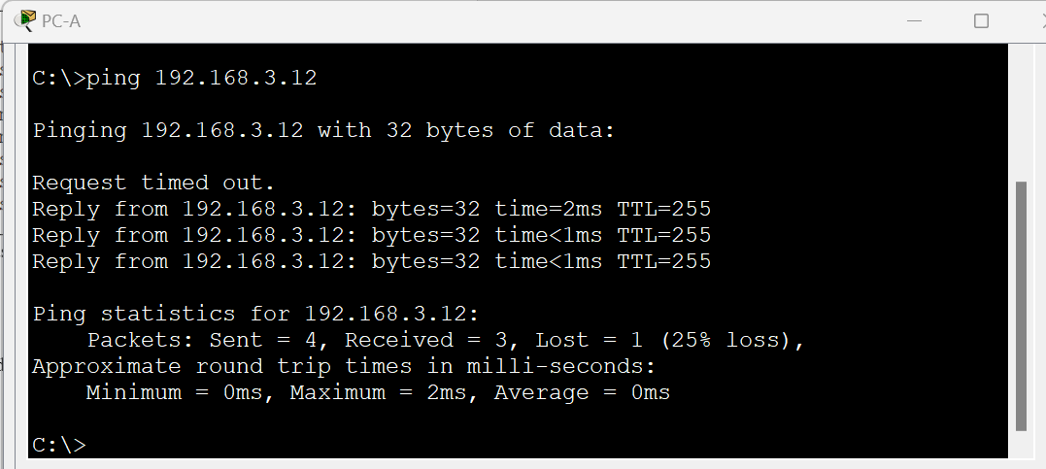

Fig 14- Ping from PC-A to S2.

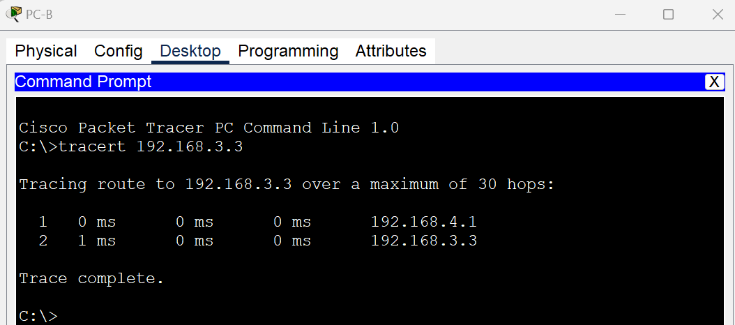

Fig 15- Use tracert from PC-B to the address of PC-A.